Goal
This high-level user testing will be used to inform future feature-level user testing.
The goals of this testing include:
- Determine the value of proposed features qualitatively
- Gather the details for designing and prototyping different features, i.e. answer the questions that we still have given the info from the user interviews
Example: what documents users might download/ upload using the app?
- Pinpoint a set of high-value features to focus on for future prototypes

Hypothesis/ Assumption
Users will be able to elaborate on the helpfulness/ unhelpfulness of the features by relating those features to their own experiences

Methods
There will be a home screen with all the proposed features and clicking on one button (representing one feature) will lead the users to the 1st screen of that feature (i.e. features with multiple screens will be represented with only 1 screen).

Users will be asked to explore the app and think out loud how they might use the app: (1) describe what they think the current screen does, (2) describe what they think will happen if they tap some buttons that seem relevant to them, (3) tap those buttons and speak about what they think and how they feel.

There will be follow up questions on each of the different screens to gather the info needed to design the feature that a screen represents

Script
"Thank you very much for having us today and helping us find out how Veterans can better access the VA’s services and benefits. We really appreciate the time you spend with us and all the information we receive from you.

Before we start, I would like to ask you if you mind if we record our conversation. We will not publish it anywhere-- we will only use it for internal documentation and analysis as it relates to this design project.

In the following 15-20 minutes, we’re going to explore how you might use an app from the VA. So I would like to ask you a few questions to learn more about this.

Then we will show you a prototype and ask for your feedback on the current concept of the app. "

Warm-up questions

[build rapport & collect info for participant description; elaborate on role, relevant factors]
- What do you usually use your mobile apps for? How would you define an app?
  - To determine level of tech comfort
- Age, when left the service, branch, use any VA services?
- Use any VA apps? Healthcare apps? Banking apps?
- ...
- ...
"So now I’d like to show you a prototype. It's an early stage in the project, so the team made a working model to get feedback on the concept before we get too far ahead.

It is also very important that we are not testing you, but we are testing our prototype and ideas. If you are confused or some things are not understandable, your feedback helps us find areas that still need to be improved. It is very helpful if you let us know.

I would like to ask you to think aloud, tell us everything that comes into your mind, good or bad. Your honest feedback is very appreciated.

Do you have any questions before we start?"

Test scenario & tasks

SCENARIO
The VA just rolled out a new app. Discover the features of the app and see whether you want to keep using the app.

TASKS
(1) describe what they think the current screen does,
(2) describe what will happen if they tap some buttons that seem relevant to them,
(3) tap those buttons and speak about what they think and how they feel.
“Are you surprised by any of the features on this screen?”
“Are there any features that you would expect to see on this screen but are missing?”
“Are the features on this screen intuitive?”

Here are the questions unique to different screens. This table helps to make sure that we gather enough information to answer our questions and/ or collect insights to come up with usable designs:
Screen | What we want to know | What we ask
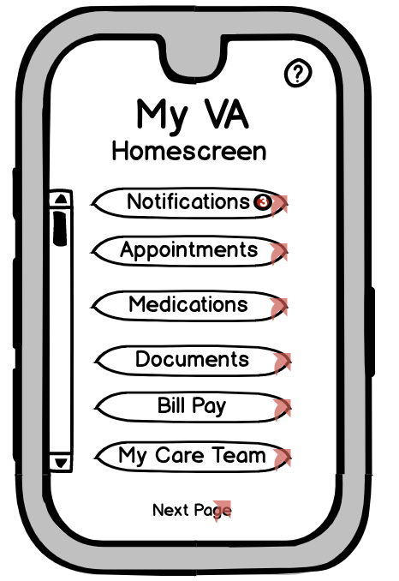 | Their thoughts on a multi-feature app  Their general expectation of the features | “What’s your first impression of this screen?”  “What do you expect this app to do?”
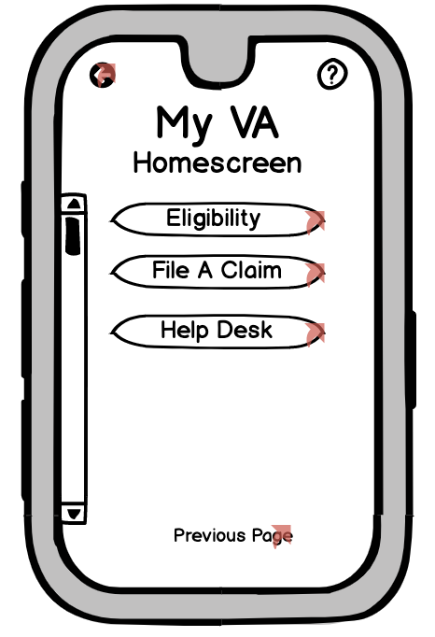
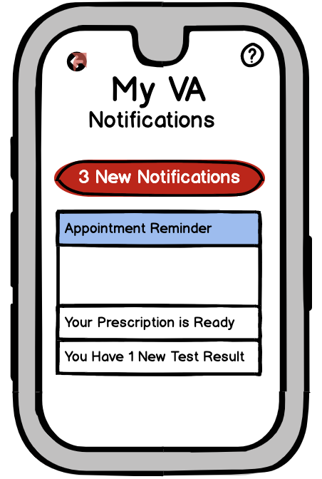 | Types of notifications that are helpful for them  Having those on an app vs. using their current methods | “What do you expect to be notified of?”  “How do you usually receive similar notifications?”
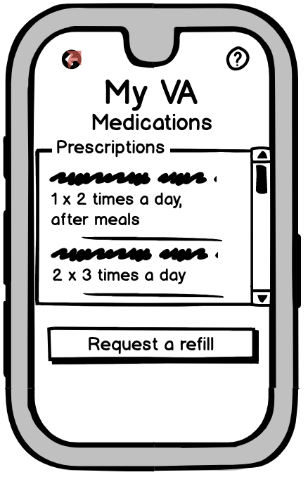 | Features related to medications  Having those on an app vs. using their current methods | “What do you expect to happen when you tap request a refill?”  “Are there tools out there that are helping you to manage medications? How do you compare having that tool and having medication in VA’s app?”
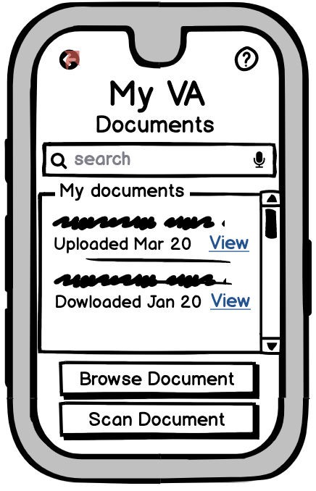 | Documents they need to access on the go  Their thoughts on uploading documents | “What documents would you put in documents? What’s the context?”  “What do you think will happen if you tap scan document? What documents would you like to scan?”
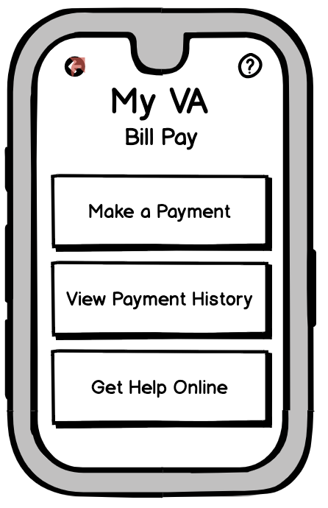 | Types of payment they prefer to make | “What service do you expect to see after tapping on make a payment?”
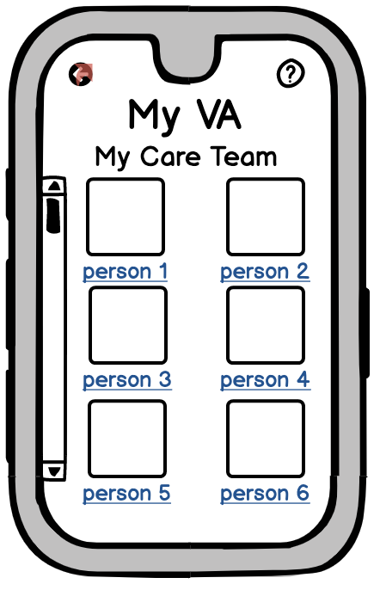 | People they need to contact (doctor? eligibility help? VA staff?) | “Who would you replace person x with?”
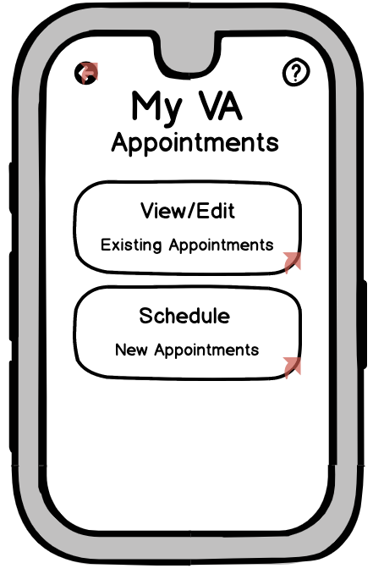 | What kind of appointments do they make?  What’s the current process like and how can we match the design to the current process?  What problems do they run into regarding appointments?
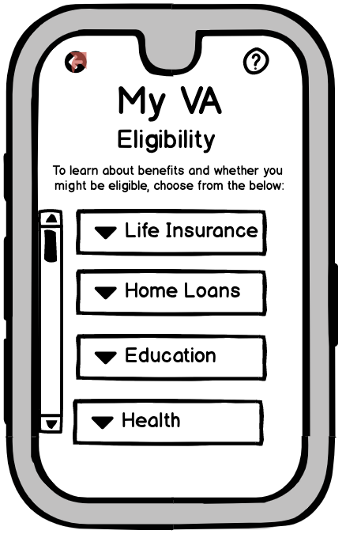 | What can be a convenient way for them to find out what they are eligible for? | “How do you find out your eligibility? Can you compare using this app to what you used?”
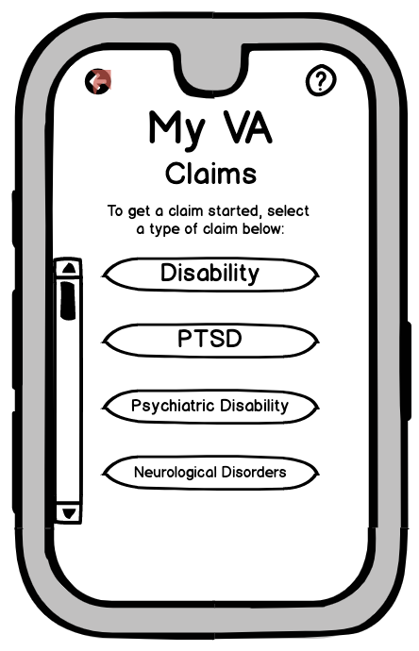 | The possibility of incorporating the app into the current claiming process | “Do the buttons cover all existing types of claim?”
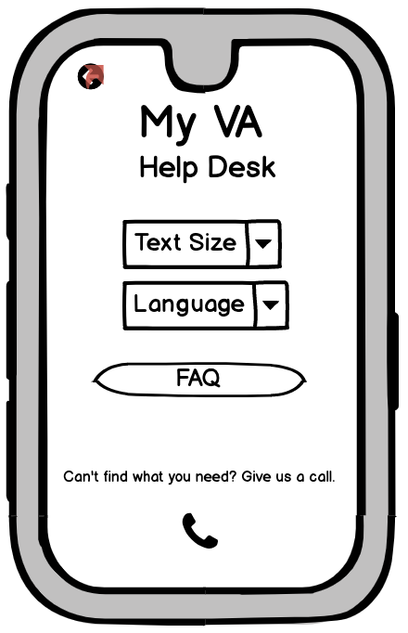 | ? | “Does this match what you expected for ‘help desk’?”  “What do you expect the FAQ to cover?”

Wrap-up Questions
- Tell me two things that you specifically liked about this prototype.
- Do you have another approach to building a helpful app for veterans?
- Anything else you want to add or ask?

